How to enable the Guest Network of my Dual-band Gigabit Router?
Product line: wireless question category: function config
Steps are as following:
1.Login to the management page of the router.
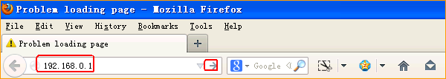

2.Input login username,password:admin, admin(default), to login, then click Advanced.
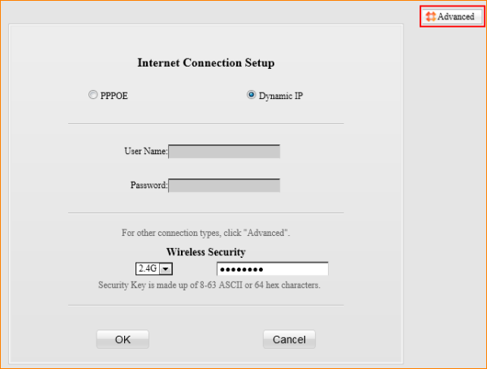
- Click on Wireless, then click on Guest Network.
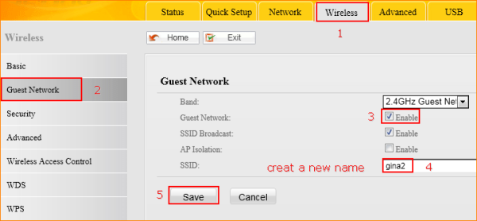
- Set a password for your Guest Network.
